num1 = int(input("Enter a number:"))

num2 = int(input("Enter a number:"))

try:

res = num1/num2

except Exception as ob:

print("Division by zero not allowed")

else:

print(num1,'/',num2,'=',res)

print("Thanks")

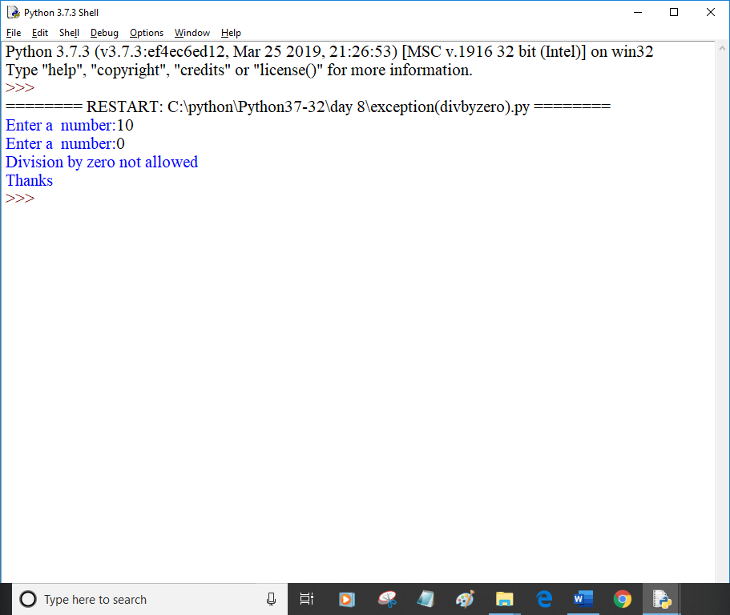

num1 = int(input("Enter a number:"))

num2 = int(input("Enter a number:"))

try:

res = num1/num2

except ZeroDivisionError as ob:

print("Division by zero not allowed")

else:

print(num1,'/',num2,'=',res)

print("Thanks")

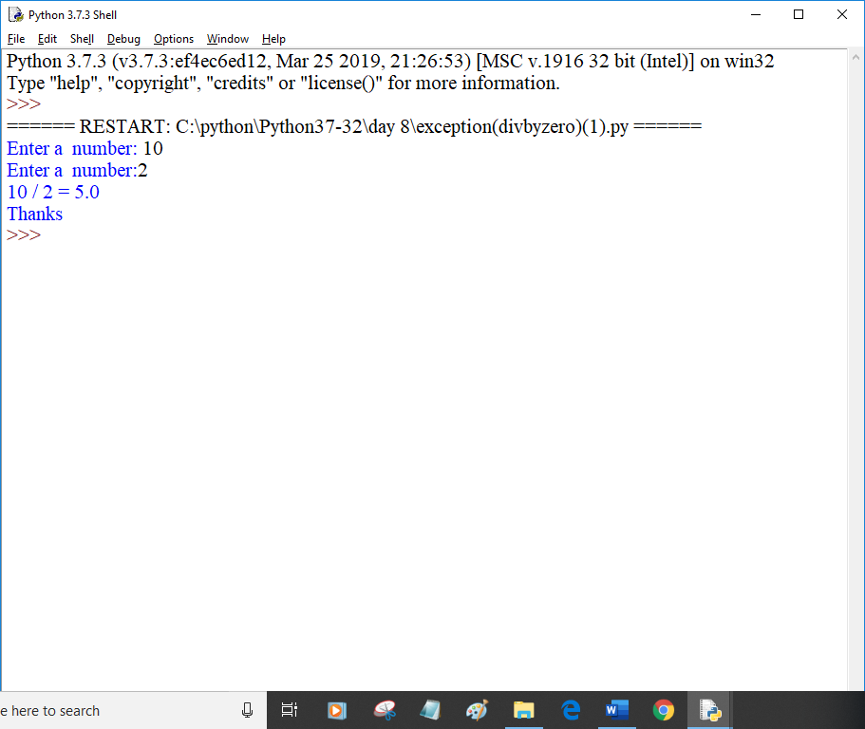

try:

import abc1

except ImportError as ob:

print(ob)

num1 = int(input("Enter a number:"))

num2 = int(input("Enter a number:"))

try:

res = num1/num2

except Exception as ob:

print("Division by zero not allowed")

else:

print(num1,'/',num2,'=',res)

print("Thanks")

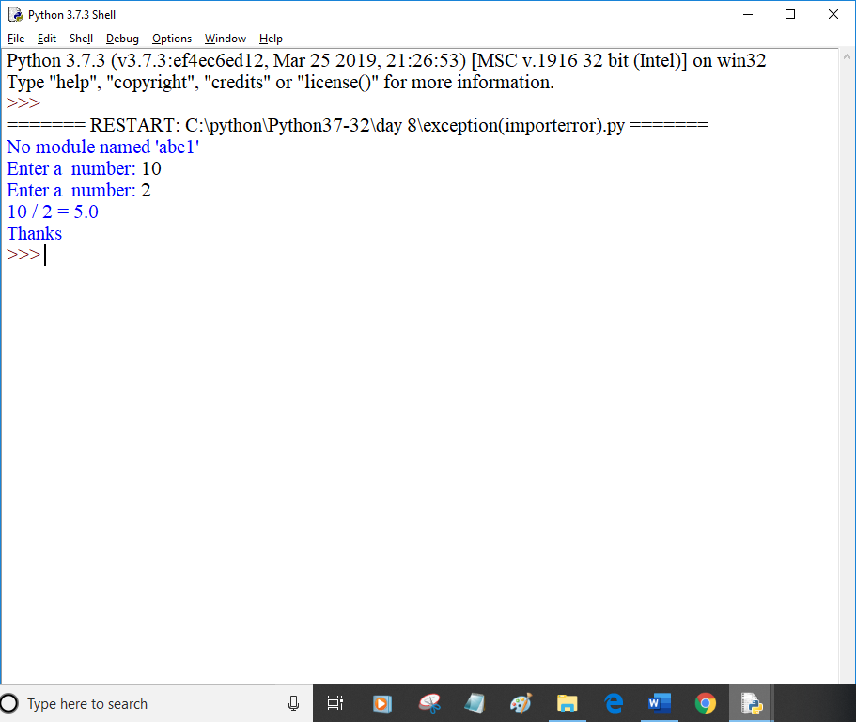

try:

num1 = int(input("Enter a number:"))

num2 = int(input("Enter a number:"))

except ValueError as ob:

print(ob)

else:

try:

res = num1/num2

except ZeroDivisionError as ob:

print("Division by zero not allowed")

else:

print(num1,'/',num2,'=',res)

print("Thanks")

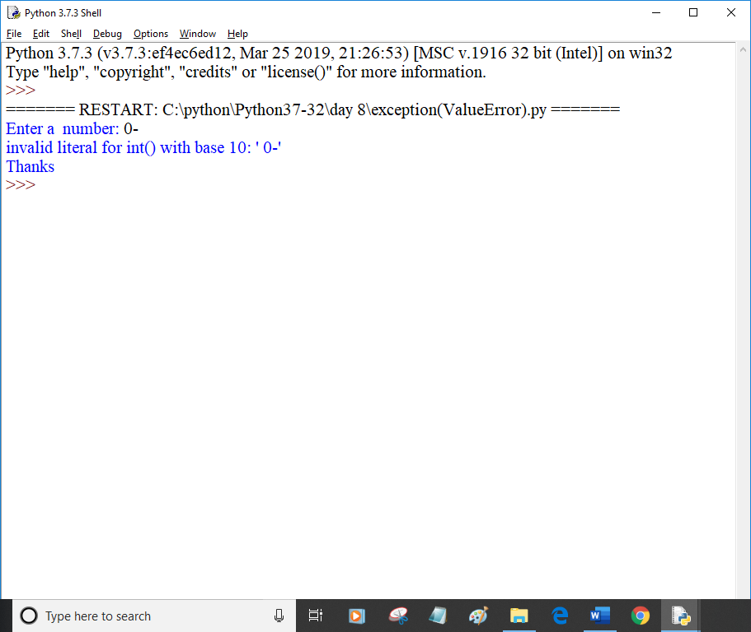

num1 = int(input("Enter a number:"))

num2 = int(input("Enter a number:"))

try:

res = num1/num2

except ZeroDivisionError as ob:

print("Division by zero not allowed")

else:

print(num1,'/',num2,'=',res)

finally:

print("Resource deallocated")

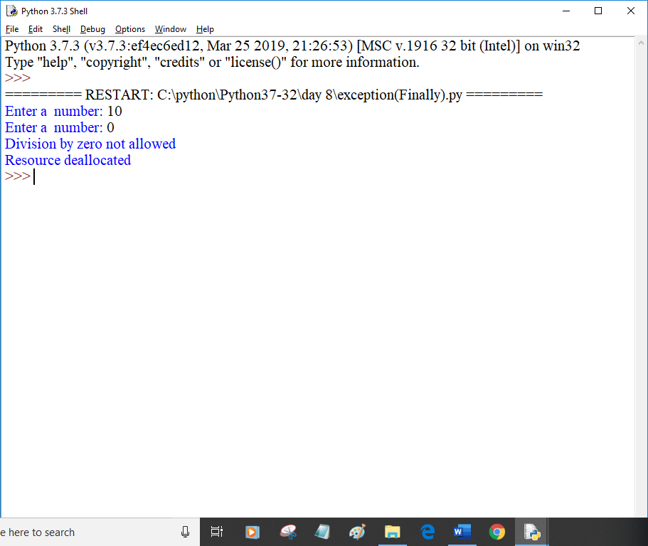

num1 = input("Enter a number:")

num2 = input("Enter a number:")

try:

res = int(num1)/int(num2)

except (ZeroDivisionError, ValueError, TypeError):

print("Division by zero not allowed or Strings are not allowed.\

Please input only integers")

except Exception as ob:

print(ob)

else:

print(num1,'/',num2,'=',res)

finally:

print("Thanks")

print("Visit again at VIPS")

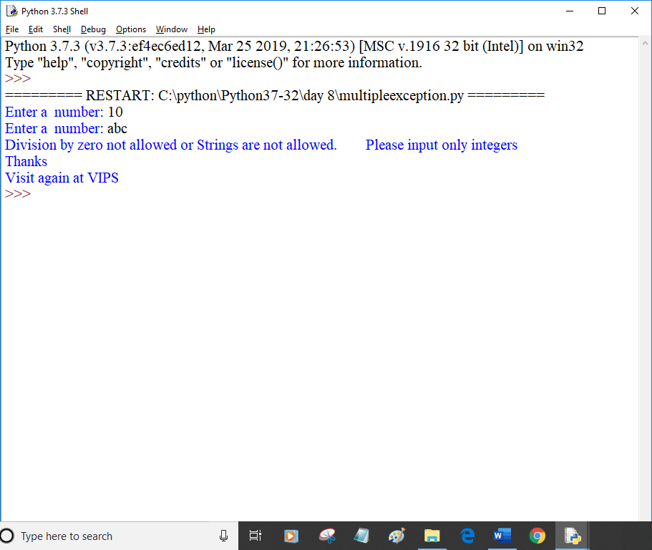

try:

fh = open(r"c:\python\student9.txt","r")

fh.write("This is my test file for exception handling!")

except Exception as ob:

print(ob)

finally:

print("Error:can't find file or read data")

try:

fh.close()

except Exception as ob:

print(ob)

print("Thanks")

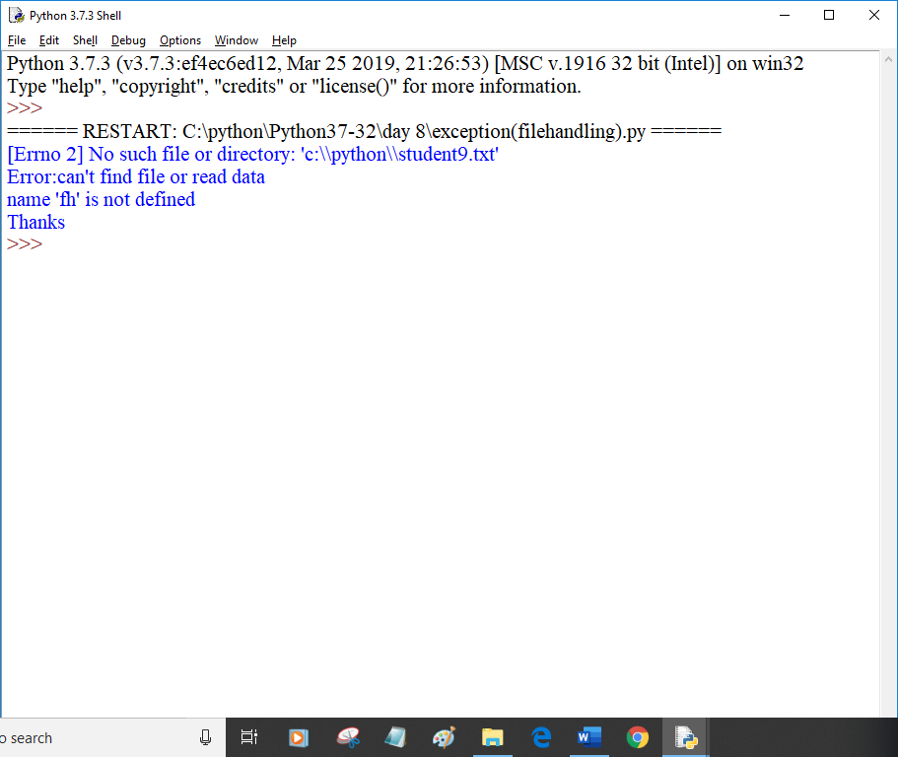

#program to perform different set operations like in mathematics

#define three sets

E = {0,2,4,6,8}

N = {1,2,3,4,5}

#set union

print("Union of E and N",E|N)

#set intersection

print("Intersectin of E and N",E&N)

#set difference

print("Difference of E and N is",E-N)

print("Difference of N and E is",N-E)

#set symmteric difference

print("Symmetric Difference of E and N is",E^N)

print("Symmetric Difference of E and N is",(E-N)|(N-E))

